**Expression of Interest – PIVOT into space**

|  |  |  |
| --- | --- | --- |
|  |  |  |

**Application Form for Grant Funding Support to**

**Develop a Technology or Innovation from its Original Application**

**to Potential Applications in the Space sector**

**Expression of Interest (EOI) Stage**

**Key dates**

|  |  |  |
| --- | --- | --- |
| Call Announced | Deadline to submit outline proposal | Projects selected to proceed to full proposal stage |
| 25 Oct 2023 | 08 Dec 2023 | 22 Dec 2023 |

|  |  |  |
| --- | --- | --- |
| Deadline for full proposal stage | Grant funding awarded from | Projects should end by |
| 19 Jan 2024 | 09 Feb 2024 | 31 Dec 2024 |

**Applying to join the programme**

This form should be used by any Midlands company applying for PIVOT into Space grant funding to develop a technology or innovation for the space sector. Proposals from companies who are not based in the Midlands may be accepted if the application demonstrates benefit to Midlands businesses – please refer to questions 3.3 and 3.4 and contact us to discuss.

We are primarily expecting applications from smaller companies, although the call is not restricted and applications from larger companies may be accepted if it can be demonstrated that their project will bring benefit to smaller companies in the Midlands area. Again, please use questions 3.3, 3.4 and 5.3 to explain this and contact us to discuss.

The Expression of Interest (EOI) stage requires provisional information about the proposed project to enable the selection of those projects which will be invited to submit a full proposal. At this stage answers should be brief and concise. You can use the size of the box as a guide to the length of answers expected. No answer should be more than 300 words. No more than 2 appendices can be added; these might include helpful diagrams, pictures, charts or plans. We strongly encourage you to ask for help completing the form. For clarification of any of the requirements, please contact the Midlands Aerospace Alliance: *info@midlandsaerospace.org.uk*.

Should you be invited to submit a full proposal, this will require more details with a programme plan, work breakdown structure and a spend schedule, but will still be kept as simple as possible and in this format. After submitting a full proposal, you may be required to make a presentation and answer questions at a panel meeting of industry experts there to help you.

**Projects will be judged against the following criteria:**

*Projects*

* Must have an application or potential application of the technology or innovation in the upstream space sector - the design, manufacture of spacecraft, payloads, systems, subsystems, and components, and the infrastructure required to launch and operate them from Earth.
* Must fit into the National Space Strategy Capability Goals (see below).
* Should ideally fit into the identified Customer Technology Themes (see below).
* Should ideally have a clear path to commercial exploitation, typically through an aerospace Prime or Tier 1 supplier.
* Should ideally have the objective to pull through new technology or innovation for use in a current or future product or manufacturing process or operations
* Must be no longer than 10 months in duration

**If your application is successful**

A project progress review and monitoring process, involving quarterly meetings, will be held supported by your assigned PIVOT into Space Technology Manager. Grant payments will be made quarterly in arrears.

**Grant funding**

PIVOT into Space grants will cover 40% of eligible spend. The maximum grant available is £50,000, which relates to a total project budget of £125,000. Eligible spend includes labour, overheads, materials, software, small items of research equipment, consultancy, travel and subsistence.

**National Space Strategy Capability Goals**

The [National Space Strategy in Action](https://www.gov.uk/government/publications/national-space-strategy-in-action) was published in July 2023. Pillar 4 from page 27 onwards describes the capability priorities.

Other useful documents are:

1. [National Space Strategy](https://www.gov.uk/government/publications/national-space-strategy) (Sep 2021)
2. [The Case for Space](https://www.gov.uk/government/publications/the-case-for-space) (July 2023)
3. [Space Exploration : Technology Roadmap](https://www.gov.uk/government/publications/space-exploration-technology-roadmap) (July 2023). A simplified list of exploration technology priorities can be found [here](https://www.gov.uk/government/news/from-ai-to-nuclear-the-technologies-driving-uk-space-exploration).

**Customer Technology Themes identified by Primes and Tier 1s – Call 2**

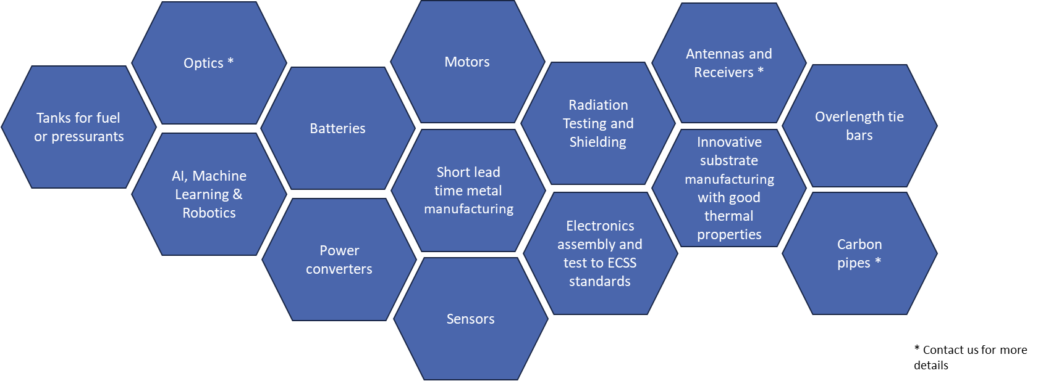

**PIVOT into Space Technology and Innovation Development Projects**

**Expression of Interest**

**What name do you wish your project to be known by? (Tip – two to five words is best)**

|  |
| --- |
|  |

*Please note that this title should be suitable for release in the public domain.*

**Section 1 New Technology / Process Involved**

* 1. **What is the new or innovative technology or process to be developed or exploited by the project? Make reference to competitors’ approaches where relevant.**

|  |
| --- |
|  |

* 1. **What is the objective and what are the expected outcomes? Define a sequence of tasks and deliverables.**

|  |
| --- |
|  |

* 1. **Why is support needed ? (What additionality will the grant provide and/or what would be done if no grant was offered)?**

|  |
| --- |
|  |

**Section 2 Technology Themes**

* 1. **Explain how the project fits into the National Space Strategy Capability Goals.**

|  |
| --- |
|  |

* 1. **Tell us how the project fits into the identified Customer Technology Themes, if applicable.**

|  |
| --- |
|  |

**Section 3 Commercial Exploitation and Benefits**

* 1. **What is the business opportunity that this project addresses?**

|  |
| --- |
|  |

* 1. **What will be the benefits to the company applying and any partners ?**

|  |
| --- |
|  |

* 1. **Do you envisage this project resulting in increased future investment? This could be investment in your firm, partners or supply networks.**

|  |
| --- |
|  |

* 1. **Do you envisage this project creating any new jobs or safeguarding any existing jobs in the Midlands?**

|  |
| --- |
|  |

* 1. **If known, explain the expected route to exploitation and when this is likely to be fulfilled. Do you foresee further technology development or an implementation phase before benefits can be obtained?**

|  |
| --- |
|  |

**Section 4 Management**

* 1. **Who will lead the project? (Company, contact name, address, telephone and e-mail)**

|  |  |
| --- | --- |
| Company |  |
| Company Reg. No. |  |
| Address |  |
| Project Leader’s Name |  |
| Position |  |
| Tel. |  |
| e-mail |  |

* 1. **What is the approximate cost of the project and what level of grant (£) are you seeking from PIVOT into Space?**

**(See page 2 for grant funding rate).**

£

£

**Total Project Cost (Funded Partners only) Grant sought**

* 1. **Roughly how do you intend to spend the budget (e.g. £staff, £necessary equipment, £subcontract £research or services, £other)?**

|  |
| --- |
|  |

* 1. **Project duration?**

**(Maximum 10 months)**

**Submission**

|  |  |
| --- | --- |
| Submitted by (Contact Name) |  |
| Company Name |  |
| Company Registration Number |  |
| Tel. No |  |
| e-mail |  |

**Please email the completed form to the PIVOT into Space team:** [**info@midlandsaerospace.org.uk**](mailto:info@midlandsaerospace.org.uk)