The Midlands Aerospace Alliance at the Paris Airshow 2011

We are pleased to announce that the Midlands Aerospace Alliance is exhibiting with its members at the Paris Airshow, 20–26 June 2011.
The International Paris Air Show - Le Bourget has been the premier and largest worldwide event dedicated to the aviation and space industry for a century. With some 2,000 exhibitors, 138,000 trade visitors, 3,000 journalists and 200 official delegations, the show indisputably remains a key point in the industry's economic cycle. It is an essential event for meeting aerospace, aviation and space industry professionals, communicating expertise, presenting innovations and becoming a player in the sector's decision-making community.
Exhibiting with the MAA

Participating in an event of this size with the MAA presents your company to world markets in the most professional way whilst taking away many concerns – costs and time being the main ones.

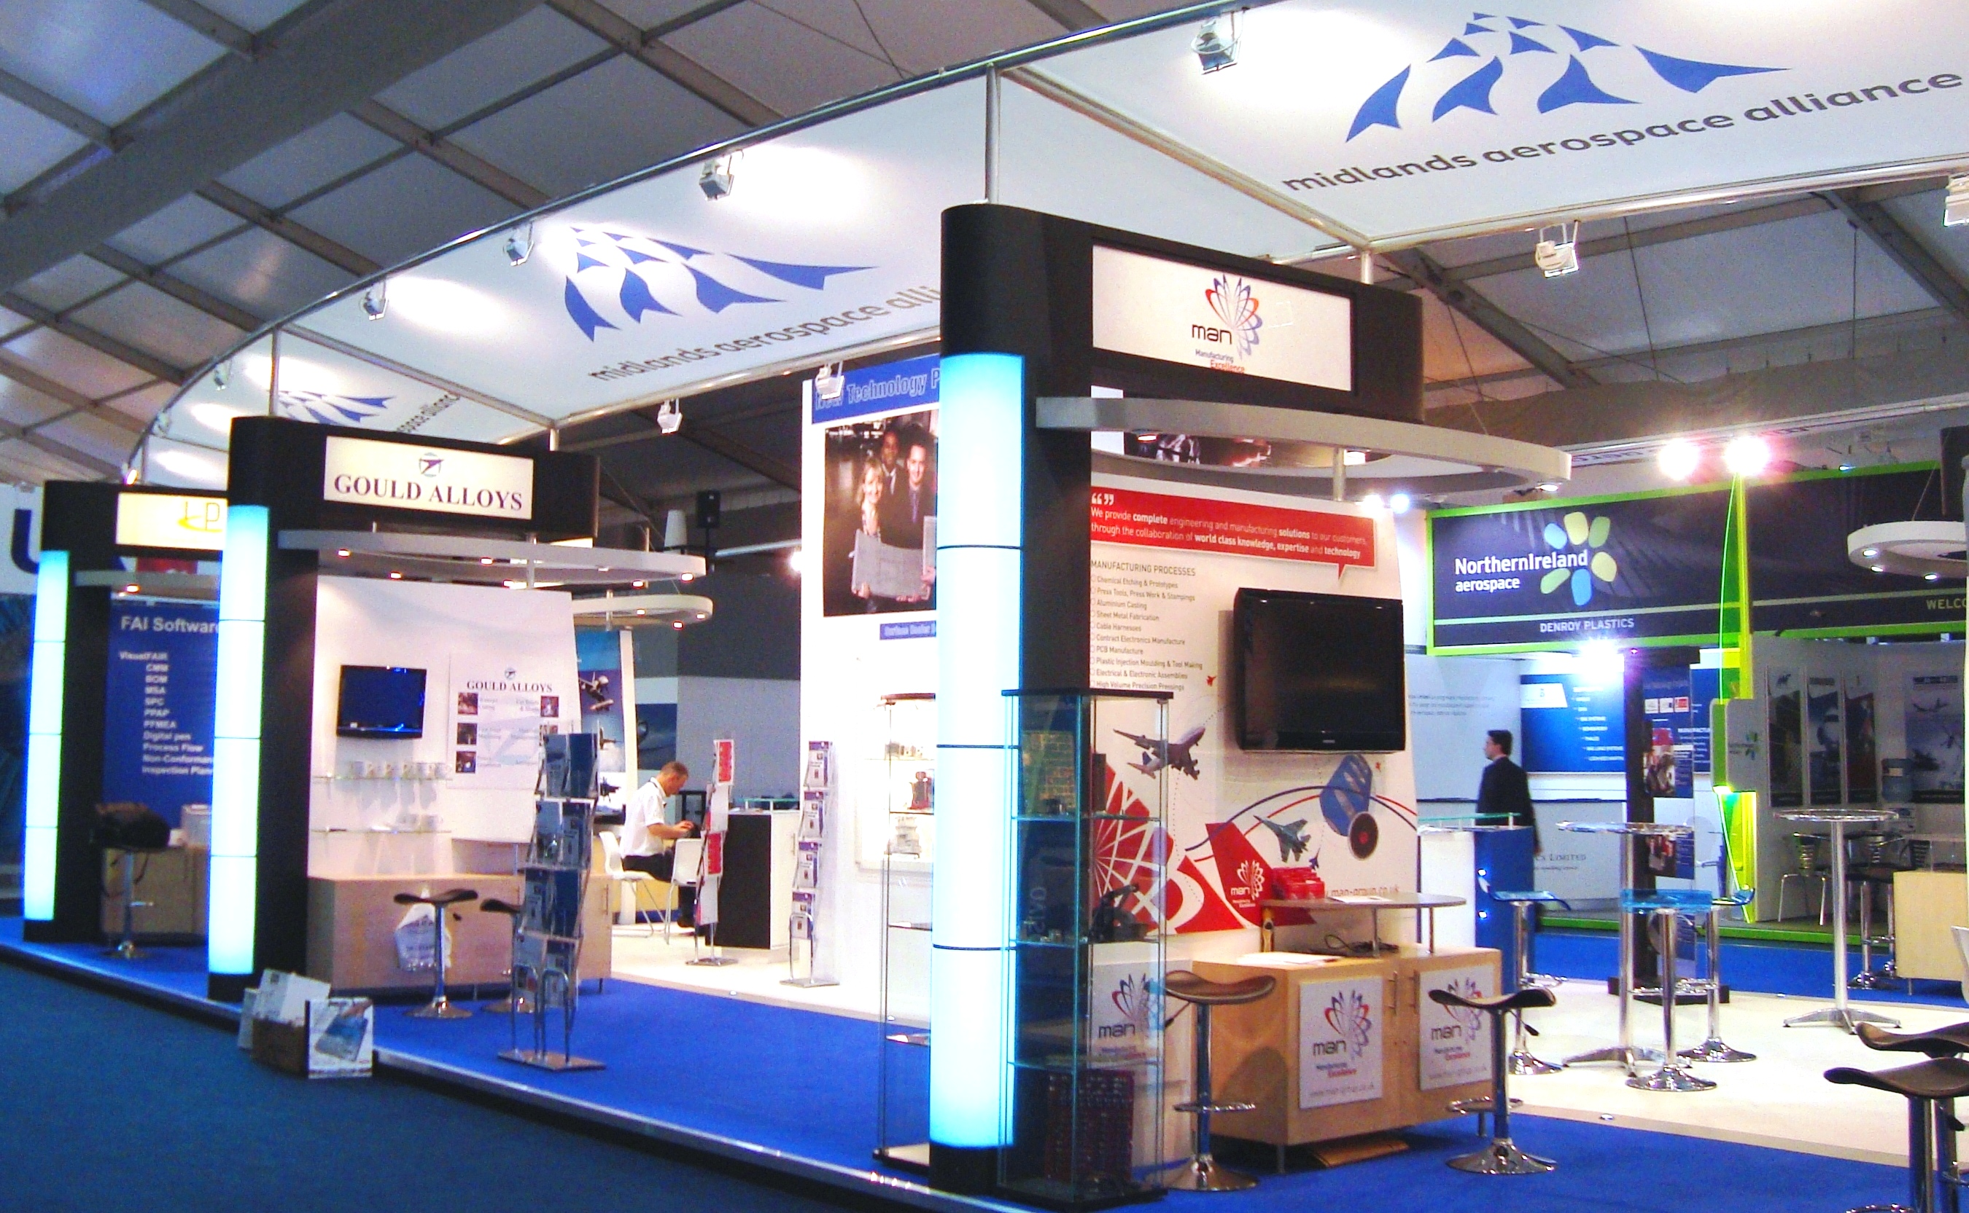
20 “pods” show off MAA members at Farnborough 2010

The MAA team works with our stand designer to give you an inclusive price where there are no hidden extras. With minimum input your company can turn up to the event welcomed by a highly visual and professional stand that presents your brand the way you want it.

The ‘pod’ stands give you an excellent base to meet with new and existing clients and that all-important physical presence to represent your company with the MAA taking enquiries while you go and meet with key contacts in the aerospace industry.

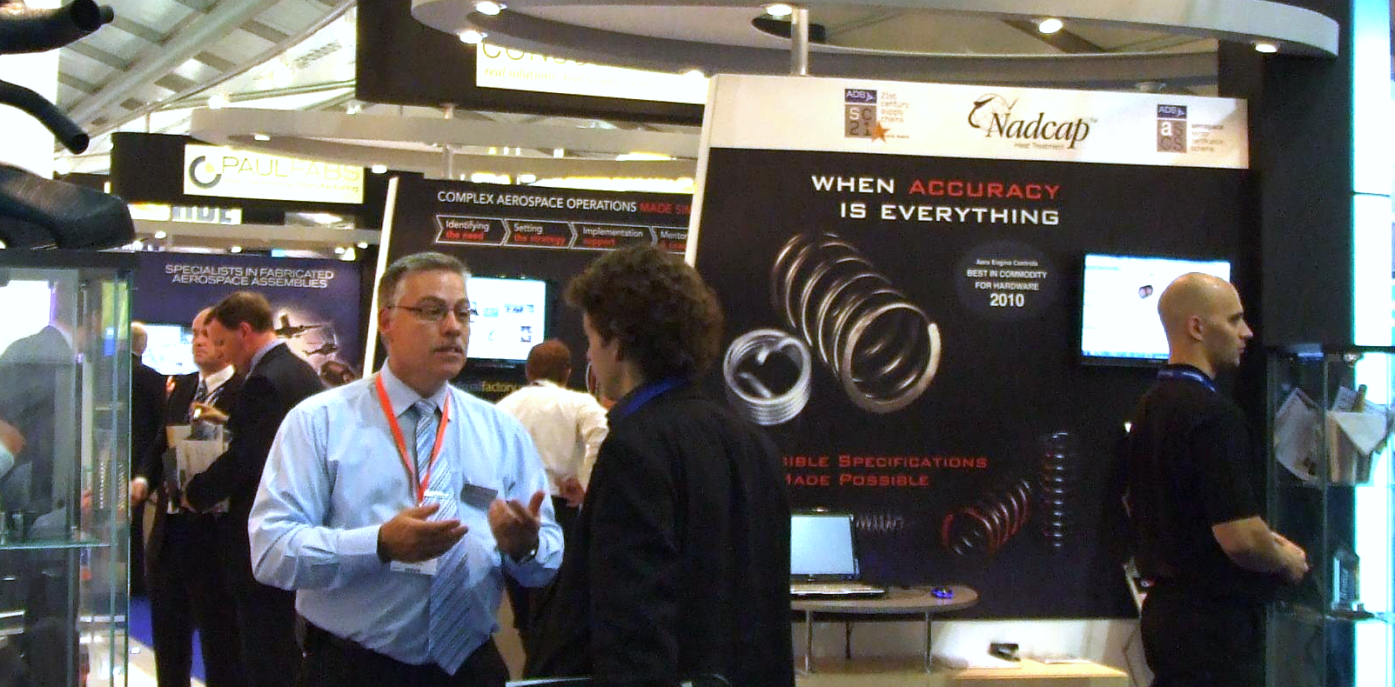
Business is brisk on the MAA stand at Farnborough 2010

Book your pod now

The MAA team moved early to organise the stand for our members at Paris so we obtained an excellent location within the “UK pavilion” at the show.

By booking space with us, we will provide you with:

- An individual pod stand including display area
- Furniture (2 stools at stand, with a lockable cabinet)
- Exhibitor Pass (valid for the duration of the show)
- 5 x Daily Entrance Tickets
- Entry in the official show catalogue
- Entry into the UK pavilion brochure
- Support from MAA staff leading up to the event, including exhibition advice for those individuals within a company that will be manning the stand
- Support from the MAA staff throughout the show
- Use of all facilities on the stand, networking and kitchen area
- Whilst on site, the MAA staff on reception will take any enquiries on your behalf if the pod is temporarily unmanned or if staff are busy

The cost to exhibit is £6,000 plus VAT.

Contact emma.burgess@midlandsaerospace.org.uk, or call 024 7643 0250 for more information.

